The Catholic Women’s League of Canada
Toronto Diocesan Council

Development Day 2023

Theme: Go Make a Difference

Saturday, February 11, 2023
9:00 a.m. Live Stream Mass
Reverend Father Liborio Amaral
Toronto Diocesan Spiritual Advisor

Morning Keynote Speaker: Honorary Life Member Barbara Dowding

THe Art of Accompaniment
(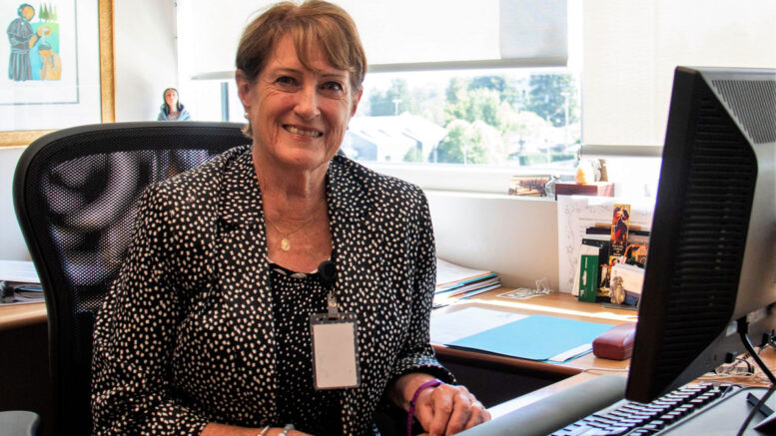

Afternoon Session (1:00 p.m.): The Beatitudes
Putting the Beatitudes into Action – To “Go Make a Difference”
In your Councils, Community, World
Presenters: TDC Standing Committee Chairs

Cost is a Suggested Donation:
$10.00/Member or $25.00/Council

RSVP: Shaila D’Souza: shailaflavy@gmail.com
Presidents, Please Register your Council on line
Please send cheques, payable to Toronto Diocesan Catholic Women’s League
to
Shaila D’Souza, 35 Lilac Ave., Thornhill, ON L3T 5K1
Presidents, when submitting your RSVP, please provide the following information for each member attending from your Council.

Parish Council Name:_________________________________________________

Region:______________________________________________

NAME | PHONE # | Email

For inquiries: Kate O’Quinn, Toronto Diocesan Organization Chair
kateoquinn@yahoo.ca

Development Day 2023
Program

9:00 a.m. Eucharistic Celebration (Live stream)
Rev. Fr. Liborio Amaral
Toronto Diocesan Spiritual Advisor
St. Mary, Brampton
9:30 a.m. Coffee Break (In your own home)
9:50 a.m. Reconvene with Zoom Access
10:00 a.m. Welcome/Introductions/Gathering Prayer
10:20 a.m. Keynote Speaker, Honorary Life Member, Barbara Dowding
“The Art of Accompaniment”
Includes: Toronto Diocese Life and Honorary Life Members sharing personal stories on who has accompanied/mentored them on their CWL journeys and Break-out room sharing
12:15 p.m. Lunch (In your own home)
1:00 p.m. The Beatitudes: Putting the Beatitudes into Action to “Go Make a Difference”
Presenters – TDC Standing Committee Chairs and includes Break-out room sharing
2:30 p.m. Closing Remarks, Prayer

"The Beatitudes are in some sense the Christian's calling card. They identify us as followers of Jesus. We are called to be blessed, to be followers of Jesus, to confront the troubles and anxieties of our age with the spirit and love of Jesus."
Pope Francis

“Go Make a Difference”

