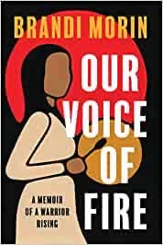
"Brandi Morin is known for her clear-eyed and empathetic reporting on Indigenous oppression in North America. She is also a survivor of the Missing and Murdered Indigenous Women and Girls crisis and uses her experience to tell the stories of those who did not survive the rampant violence. From her time as a foster kid and runaway who fell victim to predatory men and an oppressive system to her career as an internationally acclaimed journalist, Our Voice of Fire chronicles Morin’s journey to overcome enormous adversity and find her purpose, and her power, through journalism. This compelling, honest book is full of self-compassion and the purifying fire of a pursuit for justice."

