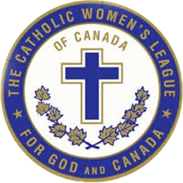

Parish Deceased Members Reporting Workshop – September 2023
Presented by: Wilma Vanderzwaag,
Spiritual Development Chair
Cathy McKinney,
Keeper of the Book of Life

If you were unable to join the workshop or you would like to refresh your memory, please click on the link below! Be cautious the passcode is case sensitive.

ZOOM Recording
Watch the Recording
Passcode: U8T$8vkP

