The Ontario Provincial Council
of The Catholic Women’s League of Canada
Invites You
To Join Us for an Evening
With Our Spiritual Advisor
The Most Rev. Bishop Thomas Dowd
and the Rosary

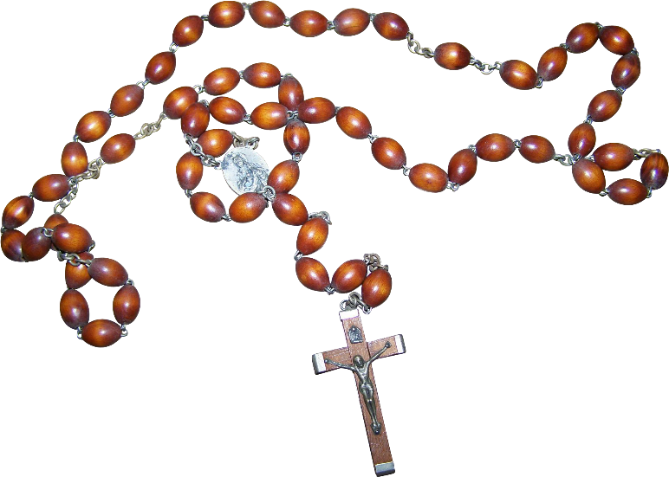
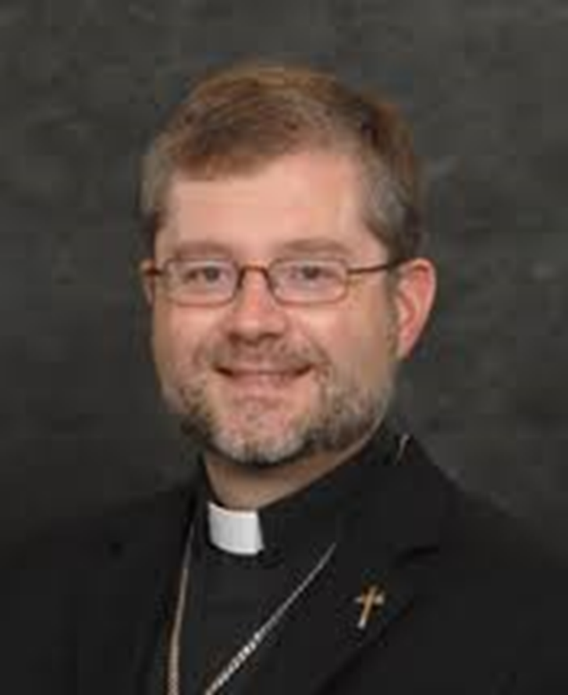
May 22, 2024 7:00pm

Please register at:
https://us06web.zoom.us/meeting/register/tZwvd-6sqz0vG9T8BjxYtN8tbD6hxB0THwf4

